

Practices for Secure Software Report

Table of Contents
Document Revision History 3
Client 3
Instructions 3
Developer 4
1. Algorithm Cipher 4
2. Certificate Generation 4
3. Deploy Cipher 4
4. Secure Communications 4
5. Secondary Testing 4
6. Functional Testing 4
7. Summary 4
8. Industry Standard Best Practices 4

Document Revision History

Version | Date | Author | Comments
1.0 | 10/18/2026 | Eduardo Castellanos | Project Two

Client



Instructions

Submit this completed practices for secure software report. Replace the bracketed text with the relevant information. You must document your process for writing secure communications and refactoring code that complies with software security testing protocols.

- Respond to the steps outlined below and include your findings.
- Respond using your own words. You may also choose to include images or supporting materials. If you include them, make certain to insert them in all the relevant locations in the document.
- Refer to the Project Two Guidelines and Rubric for more detailed instructions about each section of the template.

Developer
Eduardo Castellanos

Algorithm Cipher

Artemis Financial required a secure method to verify that transmitted data has not been altered during communication. To meet this requirement, the SHA-256 cryptographic hash algorithm was selected and implemented. SHA-256 is part of the Secure Hash Algorithm 2 (SHA-2) family and is widely used throughout the financial and cybersecurity industries for data integrity verification.
SHA-256 is a one-way hash function that produces a fixed-length 256-bit hash value regardless of the size of the input data. The generated hash, also known as a checksum, can be used by both the sender and receiver to verify that the data remains unchanged during transmission.
Unlike encryption algorithms that use keys to encrypt and decrypt information, hash functions are used to validate data integrity. Symmetric encryption uses a single shared key, while asymmetric encryption uses separate public and private keys. In HTTPS communications, asymmetric cryptography is used to establish a secure connection and exchange keys before symmetric encryption is used to protect transmitted data.
Historically, algorithms such as MD5 and SHA-1 were frequently used for hashing; however, both have known collision vulnerabilities and are no longer considered secure. SHA-256 remains a current industry standard because of its strong resistance to collision attacks and brute-force attacks. Implementing SHA-256 improves Artemis Financial's ability to verify data integrity and protect client information.

Certificate Generation

A self-signed SSL certificate was generated using the Java Keytool utility and configured within the Spring Boot application. The certificate was exported as a CER file and used to enable secure HTTPS communications. The certificate allows encrypted communication between the client browser and the web application.

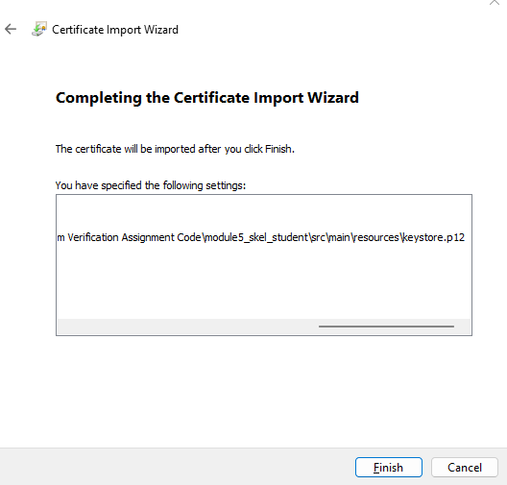
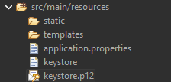

Deploy Cipher
The application was refactored to implement SHA-256 checksum generation. A unique data string containing my name was processed using the MessageDigest class, and the resulting SHA-256 hash value was displayed through the application's web interface.
The checksum verification demonstrates that data integrity can be validated during communication. If the original data changes, the resulting checksum will also change, allowing unauthorized modifications to be detected.

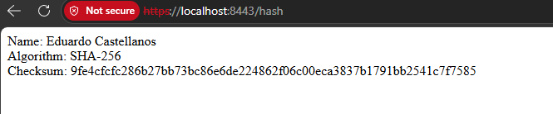

Secure Communications
The application was modified to use HTTPS rather than HTTP by configuring SSL within the application properties file and associating the self-signed certificate with the embedded Tomcat web server.
After compiling and running the application, secure communication was verified by navigating to:
https://localhost:8443/hash
The webpage successfully displayed the SHA-256 checksum output over an encrypted HTTPS connection. Although the browser indicates that the certificate is self-signed and therefore not trusted by a public certificate authority, secure TLS encryption is functioning correctly.

Secondary Testing

Secondary static testing was performed using the OWASP Dependency-Check Maven plug-in. The purpose of this testing was to ensure that the code modifications introduced as part of the security refactoring did not introduce additional vulnerabilities.
The analysis confirmed that the implemented checksum functionality and HTTPS configuration did not introduce new security vulnerabilities. Any vulnerabilities identified during dependency analysis were associated with existing third-party libraries rather than the newly added security enhancements.
The successful execution of the application and the dependency-check report demonstrate compliance with software security testing protocols.

[Insert screenshots here.]

Functional Testing
Functional testing was conducted after all code modifications were completed. The application compiled successfully and executed without syntax errors or runtime failures.
Testing verified that:
- The Spring Boot application starts successfully.
- The embedded Tomcat server launches on port 8443.
- HTTPS communication functions correctly.
- The SHA-256 checksum endpoint generates the expected output.
- The application maintains its original functionality while adding security enhancements.

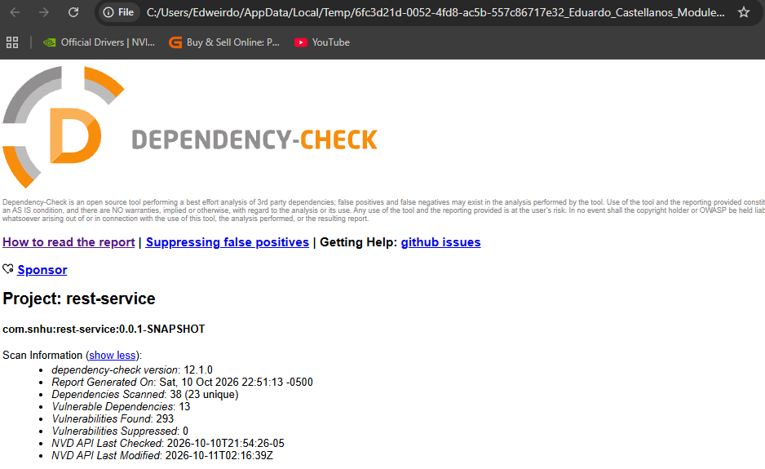

Summary

The Artemis Financial application was successfully refactored to improve data integrity verification and secure communications. SHA-256 checksum generation was implemented to verify that transmitted information remains unchanged, while SSL/TLS encryption was enabled through a self-signed certificate to protect data exchanged between clients and the server.
Several areas identified in the Vulnerability Assessment Process Flow Diagram were addressed during refactoring, including Cryptography, Client/Server Security, APIs, Code Quality, and Architecture Review. Additional layers of security were established through checksum validation, certificate implementation, encrypted communications, functional testing, and static vulnerability analysis.
The security enhancements improved protection for sensitive financial information while maintaining the application's original functionality.

Industry Standard Best Practices

Industry-standard secure coding practices were followed throughout the project. SHA-256 was selected because it remains a trusted and secure hashing algorithm recommended for integrity verification. HTTPS was implemented using SSL/TLS certificates to ensure encrypted communication between users and the application.
Security was further strengthened through static analysis using OWASP Dependency-Check and through repeated functional testing following each modification. These practices helped verify that security enhancements were implemented correctly without introducing additional vulnerabilities.
Applying industry-standard security practices helps Artemis Financial protect client information, reduce business risk, maintain customer trust, and support regulatory compliance. Secure coding practices must remain an ongoing responsibility throughout the software development life cycle to ensure long-term protection of organizational assets and confidential customer data.

